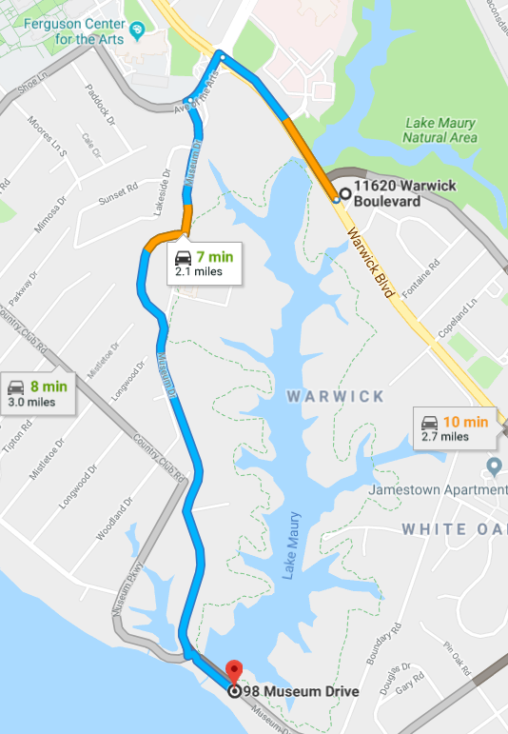

**DIRECTIONS TO LIONS BRIDGE FROM TEMPLE SINAI**

1. Leave Temple Sinai and enter Warwick Boulevard heading toward J. Clyde Morris Boulevard. Get into the left lane.
2. Make a left turn onto Avenue of the Arts (old J. Clyde Morris)
3. Make a left turn onto Museum Drive.
4. After you pass Peninsula Fine Arts Center bear to the right and follow Museum Drive down to the James River.
5. Make a left at the stop sign and park on the left side of the bridge.

**There will be Protection Service officers at the Bridge location to assist with Parking.**

Questions? Call or email

Marge Shelton

Assistant to the President

757-591-7707

mshelton@marinersMuseum.org